Welcome to the Inaugural EASC course Train the Trainer course (ttEASC). This course is designed to allow registrants and future faculty the opportunity to appreciate how the award winning EASC courses creates its impact.

EASC was first held in Donegal, Ireland in 2012. EASC courses have expanded around the World, and have been run in 12 countries, attended by over 1500 surgeons and residents. EASC is regarded by most attendees as one of the best courses they ever attended.

Course Objectives
- Understanding the goals of EASC
- How to deliver a message
- Creating audience involvement
- Overcoming personal prejudices
- Practical lecture session on Appendicitis
- How to run a Case Scenario

Who should attend ?
Consultants and Fellows who want to share their knowledge of abdominal emergency surgery and enhance their delivery of the course using the EASC curriculum

Attending this course will potentially allow you to teach on subsequent EASC course as faculty. It will create an everlasting inpression on how to deliver a crisp, exciting and perdominantly interactive educational course and learn at the same time. Knowledge is priceless. You need to register. The course will advise on how to establish an EASC course.

Michael Sugrue Pantelis Vassiliu
Fausto Catena Manos Pikoulis

Convenors

www.dcra.ie www.easccourse.com

https://www.wses.org.uk/news/wses-congress-2024-rhodes-save-the-date-25-28-june-2024

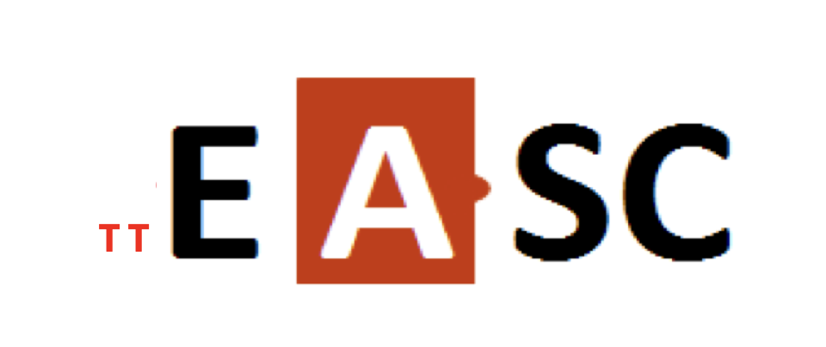
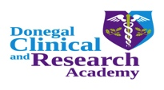

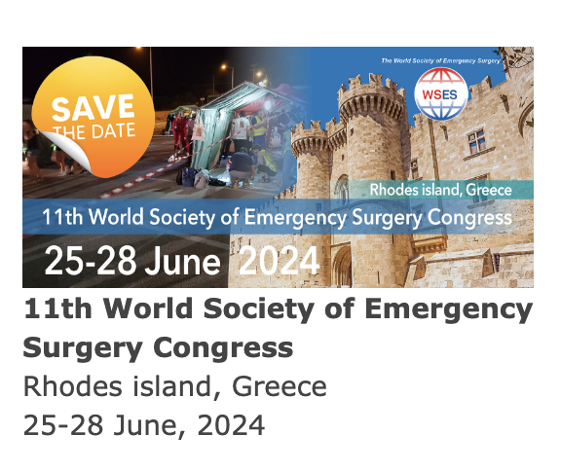

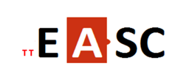

Emergency Abdominal Surgery Course

Train the Trainer Course

Sunday 23rd June 2024
CME 2 credits
Rhodos Palace Hotel
Rhodes Greece
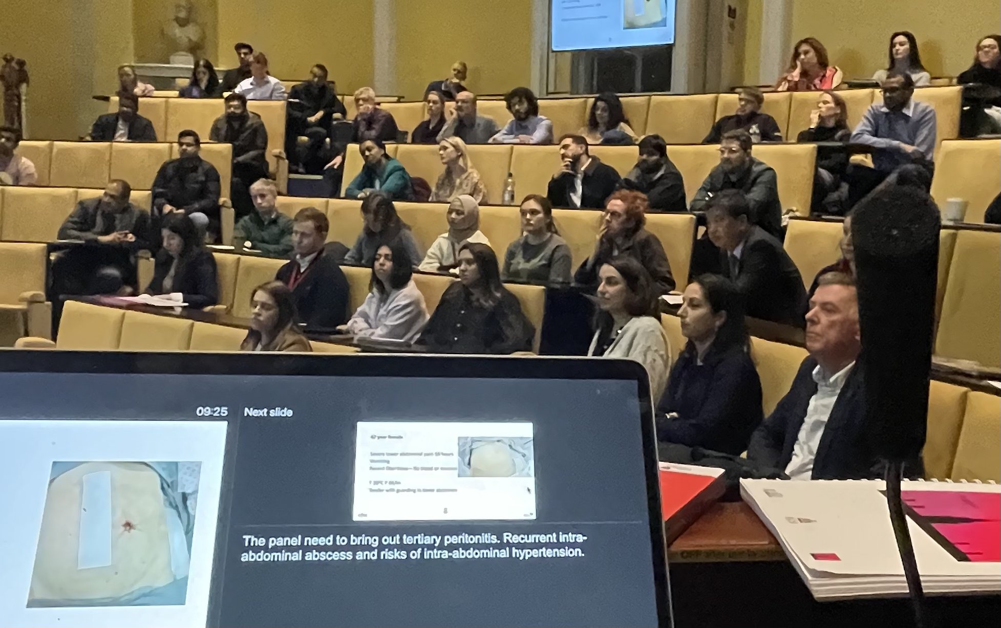

CME 2 credits

Essential to have undertaken an EASC course

Provisional Faculty

Walt Biffl USA
Richard ten Broek Holland
Fausto Catena Italy
Gustavo Fraga Brazil
Ana Maria Gonzalez Spain
Rajashekar Mohan India
Manos Pikoulis Greece
Massimo Sartelli Italy
Sandro Rizoli Qatar
Michael Sugrue Ireland
Ernest Moore USA
Pantelis Vassiliu Greece
Dieter Weber Australia

Train the Trainer course (ttEASC)

Sunday 23rd June 2024

19.00 Welcome

19.05 History and Future of EASC
Michael Sugrue

19.15 Subject Matter Expertise Overview and Quiz- Appendicitis

Testing the lecturer
How much do you really know?
Ana Maria Gonzales

19.45 Keys to Delivering a Great Lecture
Michael Sugrue

20.00 Case Scenario Panel Creating right learning environment: Cholecystitis
Weber Fausto Catena Gustavo Fraga Gonzales Biffl Moore Pikoulis Rizoli

20.30 Overcoming educational Challenges
Pantelis Vassiliu

20.38 Maintaining Quality in a Course
Michael Sugrue

20.45 Co-Hosting a Course
Rajashekar Mohan

20.52 Critieria for establishing a Course
Michael Sugrue

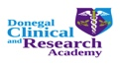

www.easccourse.com

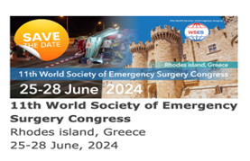

Train the Trainer course (ttEASC)

Sunday 23rd June 2024

Course Themes

- Subject Matter Expertise: .
- Passion for Teaching:
- Effective Communication Skills:
- Organizational Skills:
- Engagement and Interaction:
- Adaptability:
- Feedback and Assessment:
- Accessibility and Availability:
- Continuous Learning:
- Professionalism:
- Passion for Continuous Improvement:
- Embrace Technology:
- Empathy and Patience: Not about you.
- Research and Scholarship:
- Networking the audience
- Remembering the Team approach
- Don't take it personally.
- Asking the question for participants
- The EASC was to answer a difficult?
- Creating Humour; Love your audience

Candidates to have undertaken an EASC course

Michael Sugrue +353 877614906
michaelesugrue@gmail.com

Registration is required

Places limited

25 euros

www.easccourse.com

